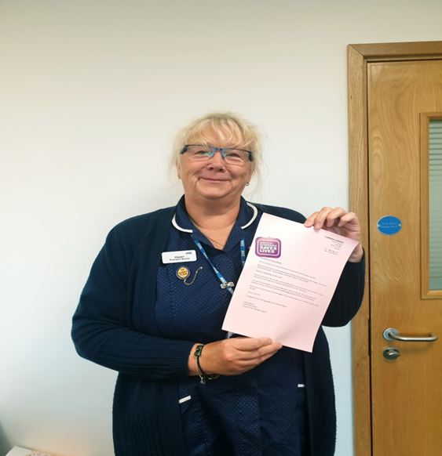

Cobridge Surgery have recently been featured in the Clinical Commission Group’s recent Newsletter for the surgeries increase smear uptake from 67-80% in two years.

This was achieved in numerous ways such as:

- All recall letters sent to patients are printed in pink as illustrated above by our Practice Nurse Hazel.

- Booking appointments at time of New Patient Check appointments if needed/ due.

- Appointments for new mums scheduled at same time as babies 12 week or 16 week immunisation appointment.

